‘EXPERIMENT 3
EXPLORATORY DATA ANALYSIS (EDA) – DATA CLEANING AND DATA TRANSFORMATION

Aim
To identify and handle missing values, duplicate records, outliers, inconsistent data, and perform data transformation techniques such as normalization and encoding using Python Pandas.
Algorithm 1
Identifying Missing Values
Step 1
Import pandas library
Step 2
Load dataset
Step 3
Use isnull() function
Step 4
Count missing values
Step 5
Display result

Program 1
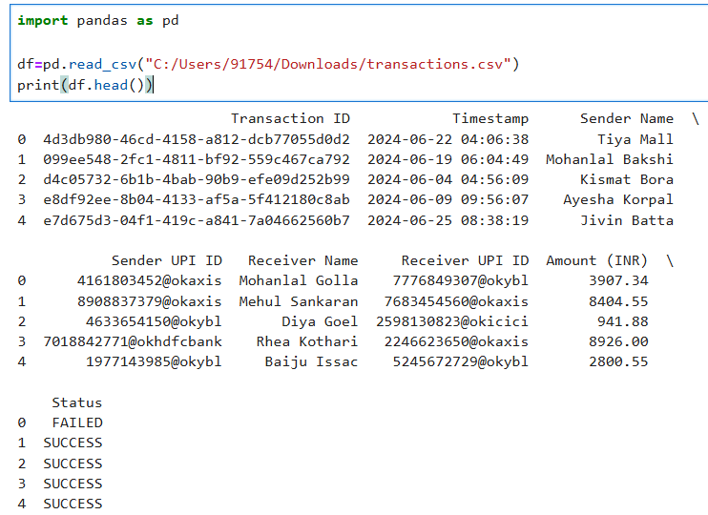
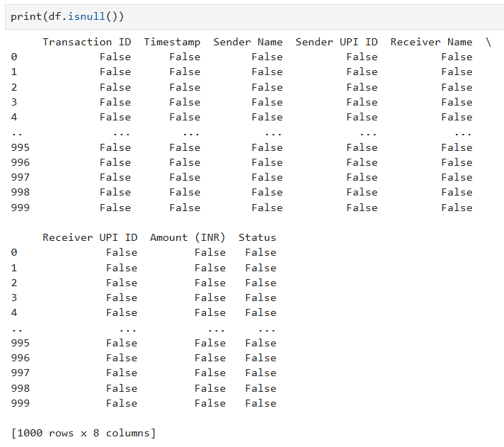
Program 2
Count Missing Values
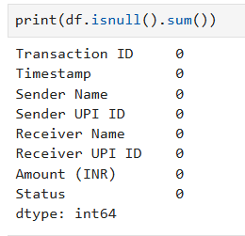
Algorithm 2
Replacing Missing Values
Step 1
Calculate mean value
Step 2
Replace null values
Step 3
Verify replacement
Program 3
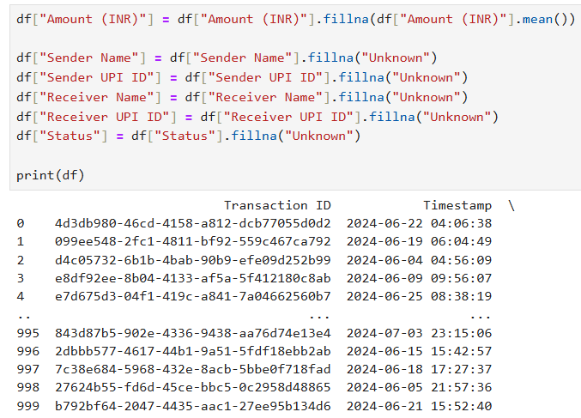
Algorithm 3
Removing Duplicate Records
Step 1
Use duplicated()
Step 2
Count duplicate records
Step 3
Remove duplicates
Step 4
Verify dataset
Program 4
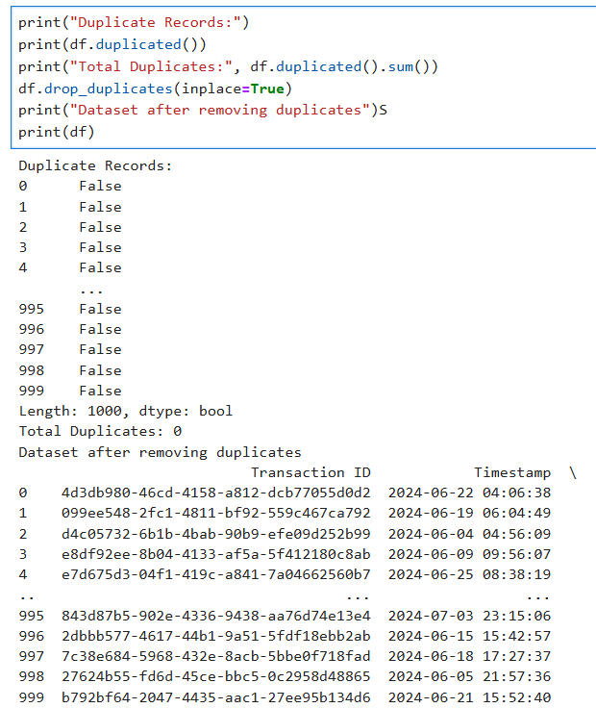
Algorithm 4
Detecting Outliers
Step 1
Calculate Quartiles
Step 2
Compute IQR
Step 3
Calculate lower and upper limits
Step 4
Identify outliers
Program 5
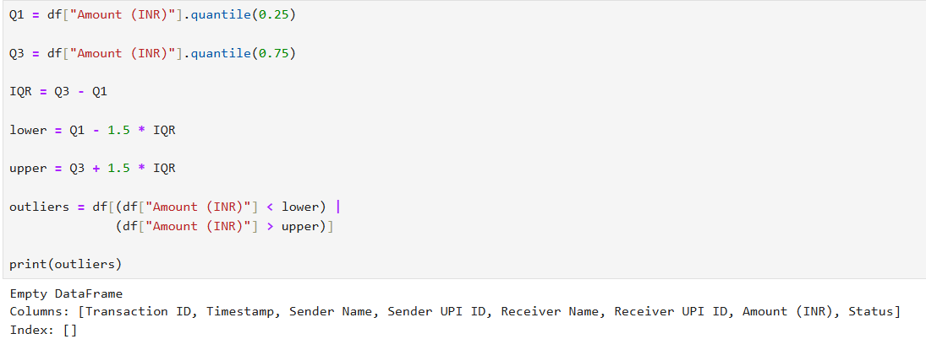
Program 6- Normalisation
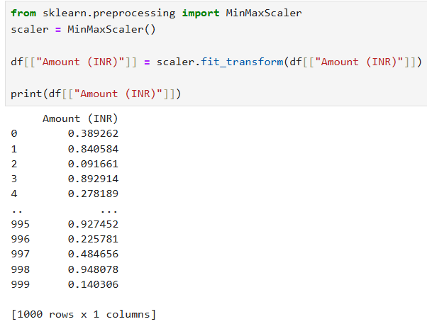

Program 7- Label Encoding
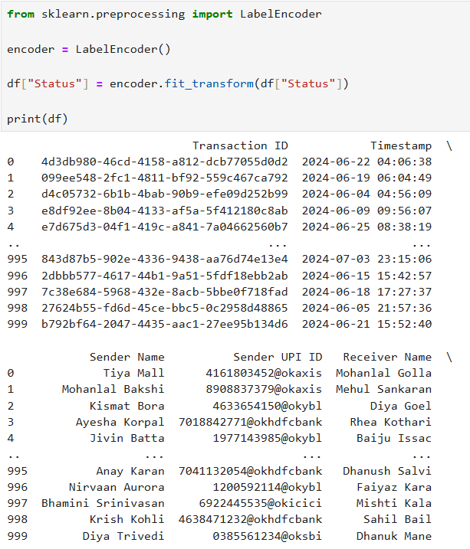

Program 8
One-Hot Encoding
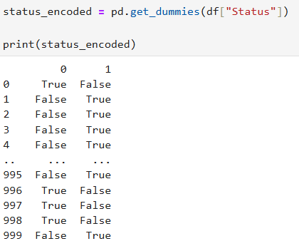
Result
Thus, missing values, duplicate records, and outliers were identified and handled successfully. Data transformation techniques such as normalization and encoding were performed, and the dataset was prepared for further exploratory data analysis and machine learning applications.

